JOB DESCRIPTION

Job Title: Supporter Relations Administrator

Salary: circa £14,430 pro rata

Hours: 30 - 37 hours per week

Responsible to: Director/FR Trustee

Responsible for: Up to 2 interns

Charity Overview: Wild Futures is a leader in the field of primate welfare and conservation, environmental education and sustainable practice. Based at our flagship project The Monkey Sanctuary in Looe, Cornwall.

Job Summary: The main purpose of this role is to coordinate the popular monkey Adoptions and Keeper for a day schemes and manage all the administrative activities linked to the Supporter Relations functions on the fundraising database. This includes ensuring that all supporter data and communication is kept accurate and up to date at all times, that all supporters are thanked in a timely manner and that mailing lists (both online and offline) are coordinated effectively. The role requires a team player who understands and works with the Wild Futures objects, aims and ethos, with excellent attention to detail, ensuring that all supporters feel valued.

Structure:
Income Generation Department

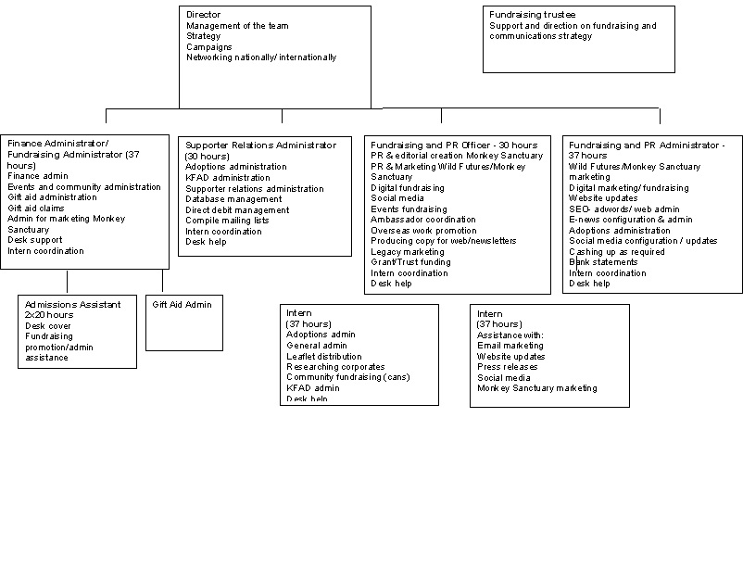

Skills & Qualifications:
Essential  Strong communicator and an ability to relate to people on all levels  Ability to prioritise and work under pressure  Strong administration, organisational and analytical skills  Attention to detail  Experience in using databases  Excellent user of Microsoft office  The ability to work as part of a team and independently on one’s own initiative when necessary  Experience in handling money  A ‘can do’ attitude  Excellent telephone manner, letter writing and email manner | Desirable  Experience of working within a target led environment  Producing reports

Job Details:

Adopt a Monkey Scheme
- Administer the adopt a monkey scheme
- Check the shop website for adoptions and process them accordingly
- Coordinate volunteers to put together adoption packs for orders and the shop
- Ensure the adoption display in the shop is kept up to date
- Put together a monthly report of adoptions received using the database and keep the record sheet up to date
- Ensure direct debit adoptions are dealt with in the correct time scales
- File all adoptions paperwork in accordance with gift aid rules
- Work with the Primate Care team to ensure that monkey updates and photographs are produced per annum
- Coordinate monthly renewal requests for annual payers and thank you renewal packs for regular payers
- Assist Fundraising and PR Administrator to generate email lists on a monthly basis for e-news and e-renewals

Database Coordination
- Ensure Advantage Fundraiser database is kept up to date – arranging backups and updates when required, liaising with Redbourn Business Systems when necessary
- Produce mailing lists for newsletter and direct mail as requested by the Fundraising Team
- Produce reports as requested by Fundraising, Accountants or Director
- Carry out a data clean on a regular basis (at least every two years) with Redbourn and ensure a deduplication of the database is carried out twice a year

Gift Aid
- Liaise with the Fundraising Trustee and Finance Administrator re being up-to-date with Gift Aid rules.
- Ensure that all data entered onto the database is in line with the Gift Aid rules so that claims can be successfully processed

Direct Debits
- Ensure that correct direct debit forms are used
- Ensure that the rules for taking direct debit income are followed
- Ensure that direct debit donations are administered within the correct time frame
- Complete Paperless direct debit training
- Use the new website Admin system to manage the online eDD for adoptions and donations
- Use Sharefile to access Rapidata(RD) direct debit reports and reconcile with the Advantage Fundraiser Database (AF)
- Liaise with Rapidata when needed
- Use BACs system for direct debit reports and reconcile with RD and AF
- Keep up to date with BACs Learning and system notices
- Check the bank statements on a monthly basis and keep up to date with direct debits paid through the deposit bank account and liaise with the Fundraising and PR Administrator when needed

Supporter Relations
- Work with the Fundraising and PR Team to assist with the annual Supporters’ Day and Christmas Open Day
- Process thank you letters to supporters in a timely manner
- Log donations on the Advantage Fundraiser Database under the correct segment/ source and fundraising activity
- Work with the Finance Administrator to ensure that all income is registered on the database and that thank you letters are sent within a timely manner
- Create letter templates and upload to Advantage Fundraiser
- Be a point of contact for supporters on the phone/ email

Keeper for a Day
- Administer the Keeper for a Day scheme, working with the Primate Care team to book in and send out the packs.
- Produce packs for the day to be handed out or coordinate a volunteer/intern to do so
- Ensure health and safety forms are filed.
- Work with the Finance Administrator to ensure the Buy a Gift process is followed for invoicing and reconcile payments on AF database
- Delegate administration of scheme to intern when appropriate

Other
- Take card payments over the phone using the AIB Merchant Management System(MMS)
- Ensure management of Wild Futures data is in accordance with data protection laws
- Keep accurate, well ordered and up to date fundraising records, facilitating electronic access to the data by other members of staff
- Produce monthly income reports on adoptions and fundraising income as requested
- Keep accurate computer and paper records, ensuring that all relevant filing systems remain effective and well ordered
- Archive data in an organised format so that any document can easily be found at a later date
- Coordinate volunteers/interns in the Fundraising office as and when available
- To be aware of current projects and workload of the Fundraising/PR Team to enable queries to be answered and attend meetings if required
- Assist with Wild Futures events if required
- Ensure that you understand and adhere to all relevant Wild Futures policies and procedures, especially with regard to health and safety
- Any other relevant work related tasks as directed by Director

