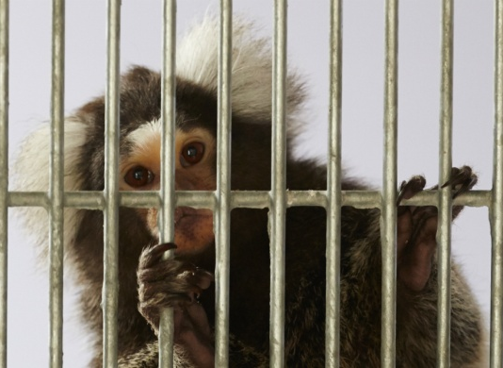
PETITION TO END THE KEEPING AND TRADE OF PRIMATES AS PETS

Thousands of primates are being confined in UK homes. Socially isolated and with inadequate stimulation, non-human primates such as marmosets, capuchins and squirrel monkeys are being kept as pets, destined for a long life of suffering in an unnatural environment. A house can never provide the complex environment a primate needs and we need the governments in the UK to act.

Full name | Email address* | Postcode | I’m happy to receive Wild Futures updates**

Wild Futures is registered charity 1102532. *By signing this petition you are giving your consent that Wild Futures can use the details to sign the online version. The petition will be handed into the governments in the UK.** If you tick the consent box you will be added to the Wild Futures email list.

