JOB DESCRIPTION

Job Title: Finance Administrator / Fundraising Administrator
Salary & hours: £14,603 hours
Location: The Monkey Sanctuary (near Looe, Cornwall)
Responsible to: Director/FR Trustee
Responsible for: Coordinating admission desk staff schedule
Charity Overview: Wild Futures is the UK charity with the holistic approach that combines an educational, environmental and sustainability remit dedicated to promoting the welfare, conservation and survival of our closest living relatives, the non-human primates; working to end the primate trade and abuse of primates in captivity, promoting the rehabilitation of captive primates and the preservation of those in the wild, whilst operating a sanctuary for primates in need of a long term home.
Job Summary: The post holder will be based at The Monkey Sanctuary and responsible for coordinating all administration in relation to our finance operations. The role requires a team player who understands and works with the Wild Futures objects, aims and ethos, with excellent attention to detail, ensuring that all supporters feel valued.
Structure:
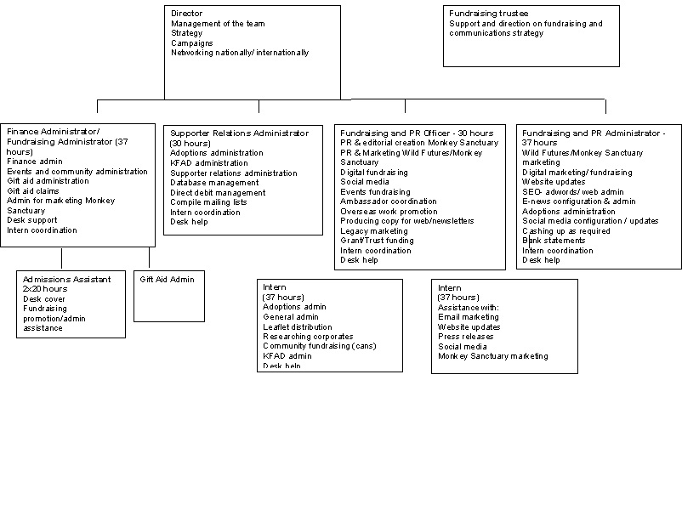

Job Details:
Main Responsibilities
Finance Administration
- To file all delivery notes
- To match up invoices to delivery notes, coordinate authorisation by the relevant department leader and send once a week to accountancy outsourced service
- Keep record of all documents sent to outsourced service
- To cash up desk income daily and record in incomes (monkey sanctuary) spreadsheet and visitors spreadsheet
- To total and record all other income in income bankings schedule daily
- To send monkey sanctuary income and bankings spreadsheets weekly to accountancy outsourced service accountancy firm
- Create new spreadsheets annually for new financial year
- To be the main person responsible for opening the post, stamping received date and recording on the relevant spreadsheets and passing to the relevant personnel
- To maintain a clear record of petty cash and safe contents
- To bank cash and cheques on a twice weekly basis at Liskeard HSBC and deal with security firm during busy open season
- To organise volunteers to count collection can income and record on a spreadsheet to email to accountancy outsourced service
- To ensure fundraised income details are passed to fundraising administrators so that fundraising database can be updated and thank you letters completed, including online giving eg Justgiving
- To record admissions discount vouchers (Smartsave) figures in spreadsheet and email once a month to Metropolis
- Reconcile payments from online sales and send to outsourced service
- To put together invoices for any invoiced income (i.e. corporate sponsors, adopters and ticket sellers) on a weekly basis and send to accountancy outsourced service
- Send Buy a Gift or similar scheme invoice to outsourced service
- To pass employee expense claims to the Director and one other manager for signing and to send via email to accountancy firm before payroll date
- To maintain details of utilities including energy, phone, water, gas, oil and inform management when deals can be negotiated. Arrange meetings as appropriate.
- Ensure insurance cover is up to date, arrange meetings with insurance companies in liaison with management.
- To answer telephone enquiries and transfer to relevant personnel
- To provide backup cover for shop manager if required
- To deal with stationery orders
- To deal with any printer issues

Gift Aid
Gift Aid
• Carry out quarterly gift aid claim online
• To ensure that the small claims gift aid process is followed and paperwork adequate and
correctly filed and logged on the Advantage Fundraiser database
• Keep up to date with the Gift Aid rules, using the HMRC site and seeking advice from the Fundraising Trustee, Accountants and Redbourn
- Ensure that all staff entering data onto the database do so in line with the Gift Aid rules so that claims can be successfully processed
- Import admissions GA income onto AF database
- Clean and check data before claiming

Fundraising & marketing administration
Record legacy notifications and actual bequests, including on database, communicate any legacy notifications and updates to the Director and follow up as necessary in liaison with Director

Personnel
- Coordinate schedule for admissions staff
- Provide starter forms for new staff and send to outsourced service when completed
- Maintain record of EVS pocket money
Ongoing Responsibilities
- To be flexible in your work according to new situations as they arise and be able to prioritise work.
- To maintain good communications with all team members.

